

**CP301**

**Developmental Engineering Project**

Topic:

Heat Loss Minimization

Under the guidance of -

Dr. Navaneeth K Marath & Dr. Devranjan Samanta  
Assistant Professors, Department of Mechanical Engineering  
IIT Ropar

Submitted by:

**Atharv Srivastava (*2022MEB1301)***

**Atharva Sharma** (***2022MEB1302)***

**Darius Johanan** (***2022MEB1305)***

**Mohit Sharma** (***2022MEB1326)***

**Index**

1. Introduction
2. Objectives
3. Problem Description
4. Background and Literature Review
5. Methodology
6. Simulation results
7. Discussion and analysis
8. Future Work
9. Conclusion
10. References

**Introduction**

In many slum areas of Punjab, particularly near Rupnagar, extreme weather conditions pose a significant challenge to residents. During the summer, temperatures rise significantly, making houses unbearably hot, while in winter, the lack of proper insulation leads to extremely cold indoor conditions. This results in a heavy dependence on cooling and heating solutions such as desert coolers and heaters, leading to high electricity bills. Most houses in these areas are built using conventional burnt clay bricks, which offer little resistance to heat transfer, making them inefficient in maintaining comfortable indoor temperatures.

Our project aims to address this issue by analyzing the heating and cooling loads of a representative sample house and identifying cost-effective, eco-friendly, and sustainable materials that can be used as insulation. By implementing suitable insulation, we aim to improve thermal comfort and reduce the energy consumption required for heating and cooling. Additionally, we conducted simulations using EnergyPlus to evaluate different insulation materials and their effectiveness under two distinct climatic conditions: Shimla (cold climate) and Chandigarh (hot climate).

Through this study, we hope to provide practical recommendations that can be implemented in slum housing to improve living conditions while reducing energy expenses for residents.

**Objectives**

The key objectives of our project are:

1. To analyze the heating and cooling loads of a typical slum house in Punjab using EnergyPlus simulations.
2. To identify and evaluate cost-effective, eco-friendly, and sustainable insulation materials that can be used to improve thermal comfort.
3. To compare the impact of insulation under two different climatic conditions:
   * Cold climate (Shimla)
   * Moderate to hot climate (Chandigarh)
4. To propose feasible insulation solutions that can be easily implemented in slum housing with minimal cost.
5. To assess the reduction in energy consumption and electricity bills by incorporating insulation in existing brick houses.

**Problem Description**

Many slum dwellers in Punjab, Haryana, and Himachal Pradesh struggle with maintaining comfortable indoor temperatures throughout the year. Most slum houses are built with brick walls, which provide limited insulation against external temperature variations. During summers, houses become extremely hot, forcing residents to rely on desert coolers or fans, while in winters, they experience severe cold, necessitating the use of electric heaters. These appliances significantly increase electricity consumption, leading to higher energy bills, which can be a financial burden for low-income families.

Our study focuses on evaluating the thermal performance of these houses and exploring insulation materials that can improve energy efficiency. We designed a sample house geometry for analysis and used EnergyPlus to simulate heating and cooling loads under different weather conditions. By considering affordable and sustainable insulation materials, our goal is to provide solutions that enhance the livability of slum houses while keeping costs low.

By the end of this project, we aim to recommend practical, implementable solutions that can make slum housing more energy-efficient, reducing both the dependency on external cooling and heating devices and the associated financial burden on residents.

**Background and Literature Review:**

Building energy efficiency is a critical factor in modern sustainable construction. Numerous studies highlight the impact of insulation materials, HVAC system design, and ventilation strategies on heating and cooling loads. Based on insights from computational investigations into energy consumption in buildings, bio-inspired materials and composite walls have emerged as promising solutions for improving thermal performance.

* **Use of Bio-Inspired Materials:** Studies have shown that materials such as rice husk, hempcrete, and sugarcane bagasse can significantly reduce heat transfer through walls, minimizing cooling and heating loads. These materials have lower thermal conductivity and higher insulation properties compared to conventional bricks.
* **Composite Walls for Energy Reduction:** Research on multi-layered walls combining different materials has demonstrated superior thermal insulation, reducing the overall energy consumption of buildings.
* **Impact of Sustainable Wall Materials:** Investigations into bio-based construction materials indicate that incorporating renewable and locally available resources can enhance energy efficiency and lower construction costs while maintaining structural integrity.

By leveraging such findings, this study aims to explore effective wall compositions and insulation strategies that can be implemented in slum areas to reduce energy dependency on HVAC systems.

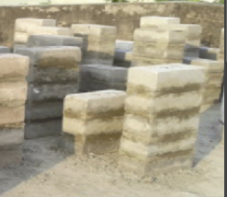

Fig.1 Sugarcane Bagasse Ash(SBA) Brick

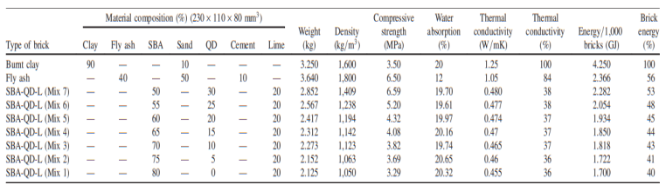

Table1 Properties of SBA Bricks

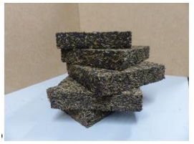

Fig. 2 Rice husk expanded cork



Table 2 Properties of Rice expandable cork

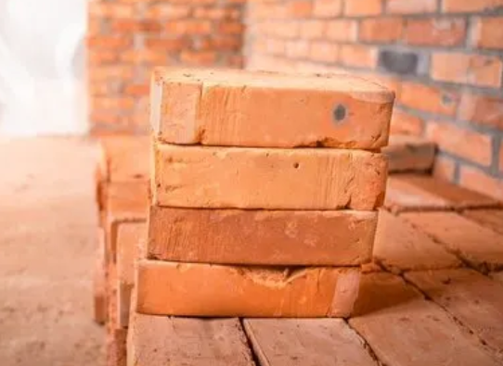

Fig. 3 Clay Brick

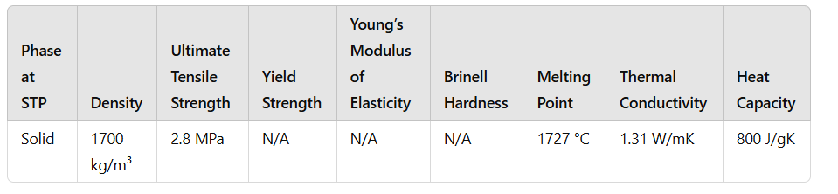

Table 3 Properties of clay brick

**Methodology**

To analyze the heating and cooling loads of a typical slum house, we used EnergyPlus to simulate different insulation setups. A sample house with defined dimensions was created in the software, and simulations were run using weather data for both Chandigarh and Shimla for the year 2023.

**House Model Definition:**

* Dimensions: 5m (length) × 3m (width) × 3m (height)
* Window: Single Pane, Located on the south-facing wall, with dimensions 2m × 1m
* **Window Materials:** Window pane has a 3mm thickness



The south-facing wall was chosen for the window placement because, in the Northern Hemisphere, this orientation allows better passive solar heating during winter. As the sun follows a lower altitude path in winter, a south-facing window can capture more sunlight, keeping the indoor temperature warmer. This passive heating effect reduces the heating load, making it an effective strategy for cold climates like Shimla.

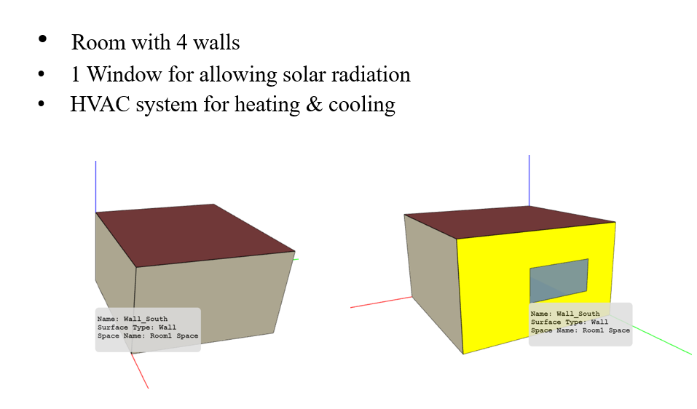

Fig. 4: Sketch of building used in simulation

**Simulation Setups:** Three different wall configurations were simulated:

1. **Control Setup:** Brick walls of thickness 22.5 cm
2. **First Material Addition:** Brick walls (22.5 cm) with an additional 11 cm layer of rice husk expanded cork bricks on all walls and roof
3. **Second Material Addition:** Brick walls (22.5 cm) with an additional 11 cm layer of sugarcane bagasse ash bricks on all walls and roof

**HVAC System for Load Calculation:** An ideal HVAC system was defined in EnergyPlus to calculate the heating and cooling loads required to maintain a comfortable indoor temperature. This was used purely for simulation purposes and does not imply that slum houses would have HVAC systems installed.

**Simulation and Data Analysis:**

* The house models were implemented in EnergyPlus, and simulations were run for Chandigarh and Shimla weather conditions using 2023 weather files.
* The heating and cooling loads were extracted in CSV format.
* Python was used to generate relevant plots and analyze the trends in energy consumption for different insulation materials.

By comparing the results from the different setups, we aim to identify the most effective and feasible insulation material that can be implemented in slum houses to improve thermal comfort and reduce energy consumption.

**Simulation results and analysis**

For Chandigarh:

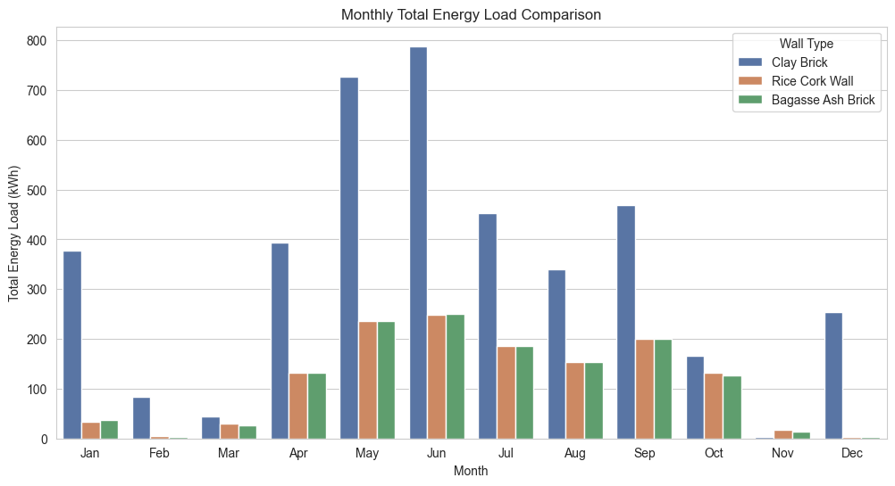

**Plot 1** Graph between Total Energy load with Months

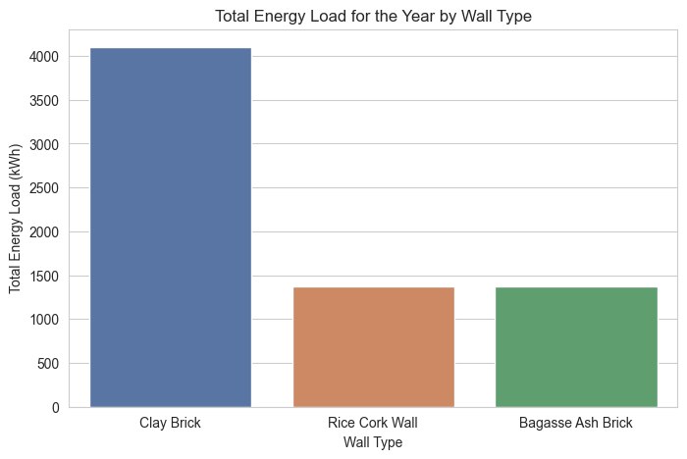

**Plot 2** Graph of Total Energy load of various walls

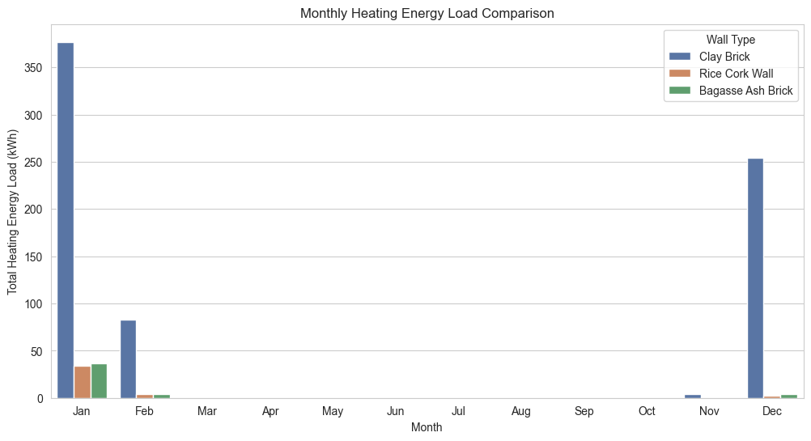

**Plot 3** Graph between Heating load with Months

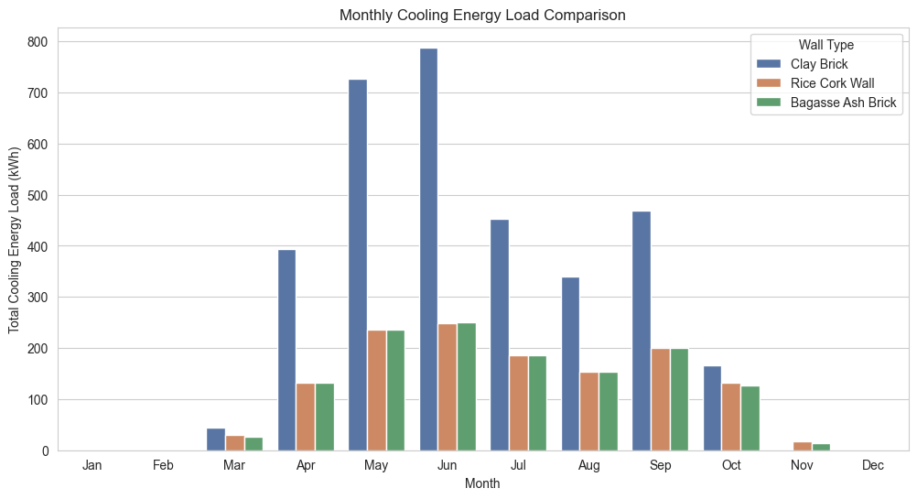

**Plot 4** Graph between Cooling load with Months

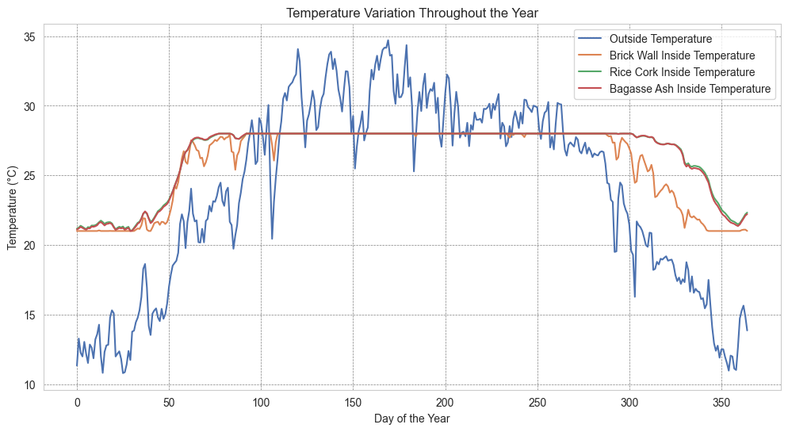

**Plot 5** Graph between Air Temperatures inside and outside building

For Shimla:

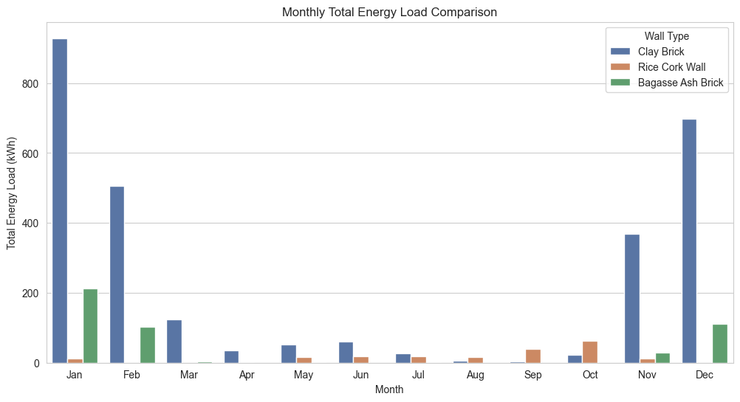

**Plot 6** Graph between Total Energy load with Months

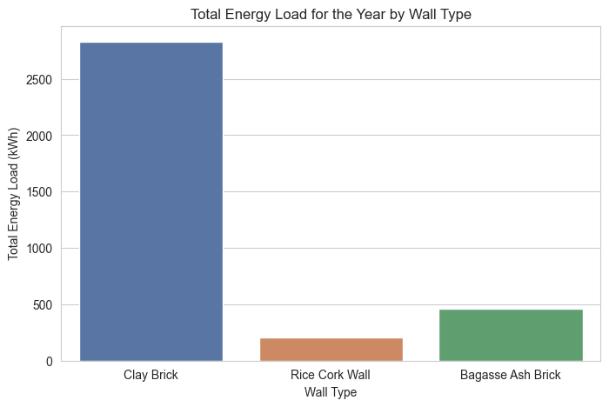

**Plot 7** Graph of Total Energy load of various walls

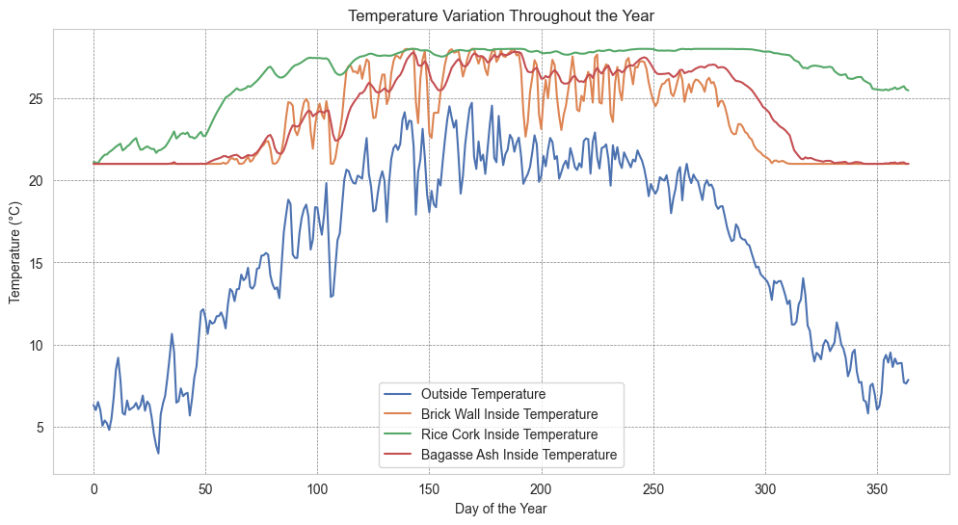

**Plot 8** Graph between Air Temperatures inside and outside building

Radius ka kaam

Analysis, Discussions, conclusion

The simulation results highlight the differences in heating and cooling loads based on material selection. Key observations include:

* **Basic Brick Wall:** Exhibited higher Rice demand due to poor insulation.
* **Rice Cork wall and Bagasse Ash Brick:** Reduced heat transfer, leading to lower energy consumption.

**Conclusion:** The study demonstrates that material selection plays a crucial role in heating and cooling efficiency. Using optimized composite walls with enhanced insulation properties can substantially reduce energy consumption. The findings support the need for integrating sustainable building materials in modern construction.

**Future Works**

To further enhance the study and develop practical solutions for improving thermal comfort in slum housing, the following areas will be explored:

1. **Ventilation and Active Cooling/Heating:** Future studies will incorporate natural ventilation strategies and investigate the impact of adding desert coolers and heaters to estimate electrical load requirements.
2. **Exploration of Alternative Materials:** Additional sustainable and cost-effective materials, or coatings that provide better insulation while reducing wall weight, will be considered.
3. **Optimized Building Designs:** Alternative architectural designs that enhance passive cooling and heating efficiency will be examined.
4. **Cost Analysis:** A detailed cost analysis of the insulation materials used in the study will be conducted to assess affordability and feasibility for large-scale implementation.

**References**